**SOP FOR**

1. **PURPOSE: Safe way for furnace top hatch opening/closing**
2. **SCOPE:** Blast Furnace Accessories
3. **RESPONSIBILITY: Engineer In charge & Maintenance Fitter on job**
4. **PROCEDURE: FURNACE TOP HATCH OPENING/CLOSING DURING SHUTDOWN**

**LIST OF TASKS COVERED:**

* Work No 1 : Top hatch opening
* Work No 2 : Top hatch closing
* Work No 3 : Cross flow pipe mounting

PPE –s to be used :

* Helmet, Co monitor, dust mask Safety shoes, hand gloves and complete sealed goggle

Aspect- Impact

|  |  |
| --- | --- |
| Dust Generation | Air pollution |
| Fire and explosion | Air pollution – SP42 |

Hazards identified

### Mechanical hazard - Fall of flange, bolts, wedges, rod etc.

### Fall of person

Physical Hazard Explosion, fire, temperature, Pressure

Chemical Hazard - Gas poisoning

Behavioral Hazards: working without all required PPE’s

Working under influence of alcohol

Horse play

Casual approach

Not following SOP/WI while carrying out the job

Work No 1 : Top hatch opening.

1. Take clearance from production for top hatch opening by taking work permit.
2. Ensure that furnace top bleeders in open condition.
3. Do carry 2 nos CO detector ~~and monitor it continuously~~ along with any authorised operation engineer.
4. After production clearance, remove the wedges of the top hatch, one by one by using hammer and remove the pins.
5. Using 2Tchain block / slowly lift the hatch by standing away from the flange for opening ~~the river side flange~~ from O2N2 side.
6. Care should be taken that the person opening top hatch should not stand directly in front of the hatch.
7. Keep the removed wedges and pins at one location so that they are not misplaced.
8. Place the ~~chicken~~ screen mesh on top of the inspection door, during the shutdown period, once top hatch is opened.

Work No 2 : Top hatch closing

1. Take clearance from production for top hatch closing.
2. Monitor Co level continuously.
3. Inspect the Copper gasket if required change the same with new one. Check the condition of inspection door, wedges and pin if found damaged replace the same. If the wedges sides are blunt grind the same.
4. Check the castable condition of this flange, if found damaged then same needs to be re done.
5. Lower the flange slowly by using 2Tchain block and insert the pins & insert the wedges in such a way that wedges matches the profile of pin and hammer till it is fully tight.
6. Ensure that all pins and wedges are fully tightened.
7. Give clearance to production by clearing the workpermit which was taken during opening the hatch.

Work No 3 **:** **CROSS FLOW PIPE MOUNTING**.

1. Take clearance from control room in charge for working at furnace top by taking work permit. This job is done in shutdown only.
2. Ensure top firing is carried out. Ensure no material in burden tank and charging hopper.
3. Ensure top hatch is kept open & bleeders also.
4. Carry 2 nos CO Monitors and ensure gas level below 50PPM
5. All tuyeres should be plugged and ensure no suction of air from tuyeres.
6. Ensure Lower sealing Valve is in closed condition
7. Mark the position on the shell of furnance as per operation requirement (ie where the cross flow pipe is to be installed) on either side (note – Both stock rod movement should not be obstructed).
8. Using Gas cutter set, cut off the shell area at the marked position (i.e. either side) so as to pass the pipe through the shell. (ensure both cut positions are in aligned position and symmetric so that the pipe passes through with ease)
9. After the cutting off the shell is completed insert cross flow pipe through the shell with the help of chainblock by pulling from opposite side.
10. Close the excessive opening around the cross flow pipe by welding plate on either side.
11. Support to be welded for cross flow pipe on the outer side of the shell (for stability/ strength).
12. Insert the gland in housing and tighten the nuts for sealing.
13. Insert the 5 nos pipes 17.2 OD( 3nos from one end &2nos from another end ) for instrumentation probe & cable insertion inside the furnace, ensure that all pipe ends should come out from slots provided on crossflow pipe at furnace inside area.
14. Weld the above pipes to the external flange with SS rods.
15. After insertion of cross flow pipe is done inform Instrumentation dept. for further connections.

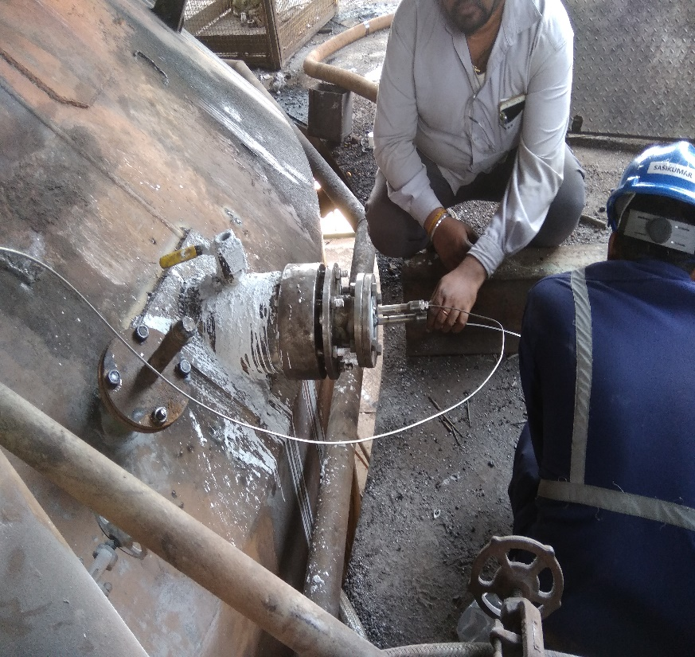

1. Close the top hatch.
2. Clear the work permit.

DO:

1. Monitor Co levels continuously.
2. Stay at least two persons at a time.

DO NOT:

1. Stand in front of inspection hatch while opening.

**Amendement Record**

|  |  |  |  |
| --- | --- | --- | --- |
| **Date** | **Manual Section Ref. & Para** | **Brief details of Revision** | **New Rev.** |
|  |  |  |  |
|  |  |  |  |
|  |  |  |  |

|  |  |  |
| --- | --- | --- |
| **Prepared By:**  Digital head VAB | **Reviewed & Issued By:**  Management Representative | **Approved By:**  Mechanical and Asset Integrity Head VAB |
| **Signature:** | **Signature:** | **Signature:** |
| **Review Date: 15.07.2023** | **Review Date: 15.07.2023** | **Review Date: 15.07.2023** |